**USB to TTL Serial cable(tx,rx)**

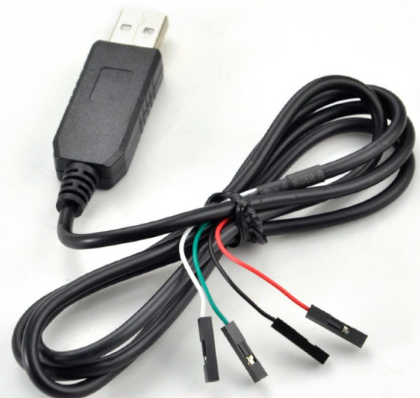

Connect one end to PC and short other end of tx, rx.

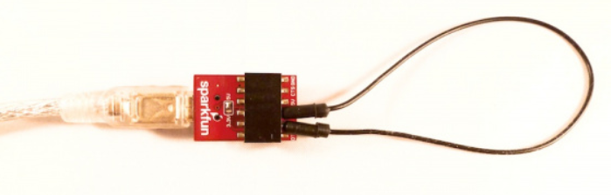

Go to device manager and check for its common port

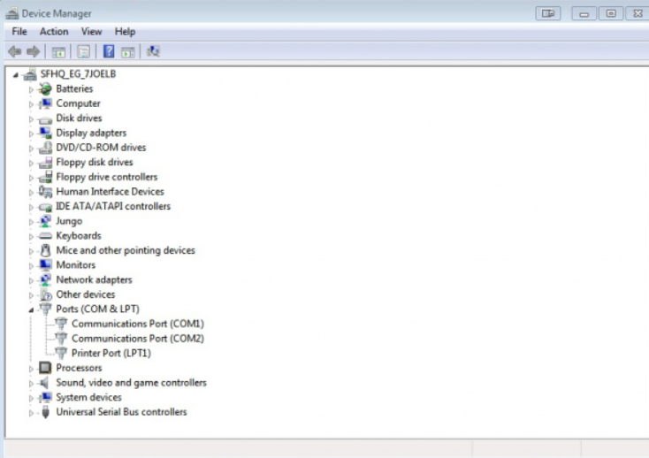

Open putty and write the com port detected and select serial.

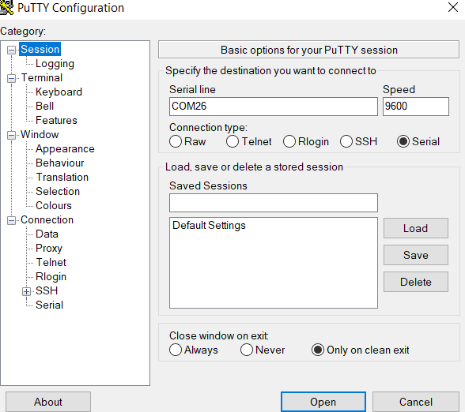

Enable echo on()

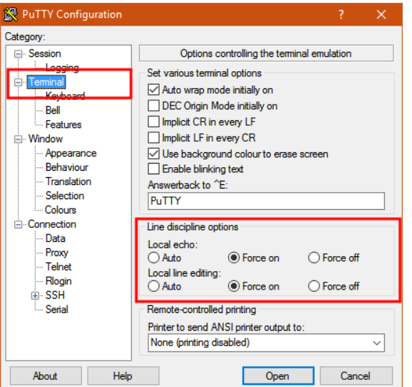

Go to serial and update the com port

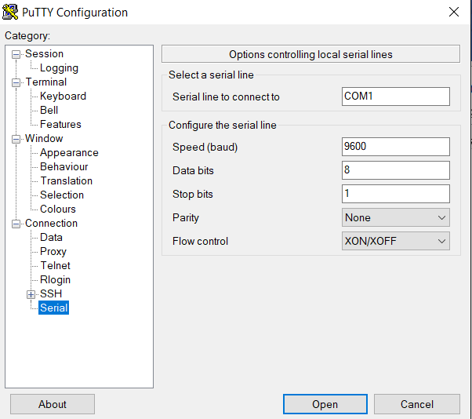

Click open

Connection will be established.

Write the data to be transmitted.

The same data will be received.